
TANWEER KHAN
MBA IT & Finance
ERP Solution Architect & IT Operations Expert

15+ Years Experience in Manufacturing Industry

tanweer.india@gmail.com
+91 9204850754

- Professional Synopsis
15+ years of expertise in business process optimization and operational efficiency enhancement. Currently Manager – IT at Metalwork Industries Limited, leading ERP implementations across manufacturing, foundry, and forging divisions. Proven in full-cycle ERP delivery, technology adoption (cloud, AI, automation, analytics), cybersecurity governance, and Industry 4.0 initiatives, SAP MM, EDI integration, and IoT. Strong manufacturing domain expertise supporting global OEMs including customer Volvo, Nissan, Ford, and Cummins Worldwide.

Professional Experience

- Manager IT- ERP Jan 2021 - Present
Metalwork Industries Limited
Jamshedpur, Jharkhand | Reporting to Group CFO

- Led end-to-end Microsoft Dynamics 365 Business Central ERP implementation across multiple manufacturing units in all modules Sale, Purchase, Production Store & Account
- Managed customization of financial modules including GL, AP, AR, and Fixed Assets
- Coordinated with CFOs, Directors, and vendors ensuring on-time, on-budget project delivery
- Provided comprehensive training and post-go-live support to 200+ end-users
- Drive adoption and enterprise-wide implementation of emerging technologies—including cloud platforms, AI, automation, Business analytics, Machine Learning and ERP solutions—supporting ongoing digital transformation initiatives.
- Lead and execute IT strategy to continuously improve operational efficiency through process automation, system optimization, and data-driven decision-making.
- Ensure robust cybersecurity posture, data protection, and regulatory compliance by enforcing effective IT governance frameworks and proactive risk management practices.

- Manager IT- Operations Sep 2017 – Dec 2020
American Excel Manufacturing (AAM)
Jamshedpur | US-based MNC, $8B global turnover

- Managed IT operations for global manufacturing sites with international team collaboration
- Led integration projects during Metaldyne & AAM merger including Oracle ERP, other Software Applications, MPLS activation and infrastructure modernization
- Handled IT budgeting, procurement, asset management, and vendor relationships
- Represented India sites in global IT operations and disaster recovery planning meetings

Assistant Manager IT Oct 2010 - Aug 2017

Metaldyne Industries Limited

Jamshedpur | IT Administrator Role

• Maintained Dell R430 Server with Windows Server 2008/2012 and Active Directory

• Managed software installation, patching, and system maintenance operations
- Managed EDI projects for global customers including Ford, Volvo, Nissan & Cummins
- Administered Active Directory, SQL Server, and Windows Server environments
- Implemented barcode scanning systems with 1D/2D label printing solutions
- Provided daily MS Dynamic NAV ERP support across all departments during critical operations


Technical Skill

ERP & Business Systems

Microsoft Dynamics 365 BC 95%

SAP MM (Materials Management) 70%

AI & Emerging Technologies 80%

Power BI & Reporting 70%

Infrastructure & Technologies

Windows Server (2008/2012/2016) 95%

Cyber Security (Black hat) 80%

EDI Integration (ANSI X12) 60%

IoT & Industry 4.0 80%

Additional Technical Competencies
- SAP MM Configuration & Implementation
- Procurement Process (P2P) Management
- Vendor Master Data Management
- Training for End Users on the MM Module



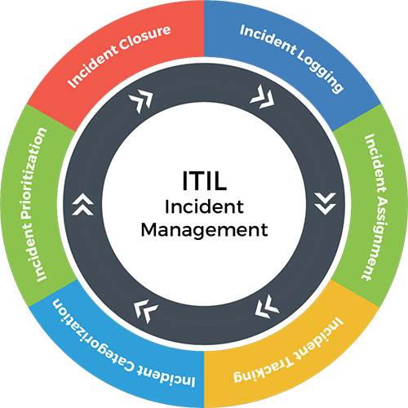
ITIL Service Management
Incident management


AI & Emerging Technologies

• Claude AI
• AI-Assisted Development (Vibe Coding)

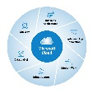
Microsoft Cloud Solutions
Microsoft Dynamics 365 Business Central


Cyber security Analysist
Ethical Hacker …Persuing


Key Projects & Achievements:

Microsoft Dynamics 365 BC Implementation
Led comprehensive ERP deployment across 2 manufacturing units, 2 foundries, and 1 forging company, optimizing Finance, Procurement, Inventory, Sale and Production workflows.
ERP Implementation Process Optimization Change Management

EDI Integration Solutions
Successfully integrated EDI solutions for global clients including Ford, Volvo, Nissan, and Cummins, reducing transaction time by 60% and improving data accuracy to 99.8%.
EDI Standards Global Integration ANSI X12
Infrastructure Modernization
Led multiple IT infrastructure projects including server upgrades, network optimization, and cloud migration, achieving 99.9% system uptime and reducing operational costs by 30%.

Server Management Network Optimization 99.9% Uptime
IoT Industry 4.0 Initiative
Designed and implemented IoT systems for real-time data monitoring, integrating sensors with cloud platforms for smart automation and improved manufacturing efficiency.
IoT Implementation Real-time Monitoring Smart Automation

Education

MBA - IT & Finance 2023
Rabindranath Tagore University
Madhya Pradesh, Bhopal

BCA - Bachelor of Computer Application 2017
Dr. CV Raman University
Chhattisgarh, Bilaspur


Certifications:
Microsoft Certified Professional (MCP), 2008 (Exams 70-270 & 70-290)
Online Business Analytics & Machine Learning, Indian Statistical Institute (ISI), Kolkata, 2026
Artificial Intelligence (AI) technologies to enhance productivity and problem-solving.
Continuously developing Cybersecurity expertise through self-learning and security best practices.


Personal Dossier
Date of Birth : 01.01.1984
Marital Status : Married.
Languages : English, Hindi, Urdu & Bangla
Hobbies : Travelling, Playing & Meeting with new peoples.
Passport : Yes.
Date Signature

